

Class of 2024 Grad Info Sheet
5 Easy Steps for the Class of 2024
Step 1: Decide on package that fits YOU
(All Cap & Gown & School required items are included in ALL Packages!)
Step 2: Turn in order form & Deposit on Order Day
Or simply go to JOSTENS.com.

Step 3: Get YOUR Official Pre Delivered Items
Step 4: Make payments on YOUR items
Step 5: GRADUATE
*ORDER ON TIME TO AVOID LATE CHARGES*
It’s YOUR time to show off!
Get YOUR official Class of 2024 Items on ORDER DAY!
(Official Class of 24 Shirt (2 Pack), Key Ring, Sling Bag, Stacked Tassel)
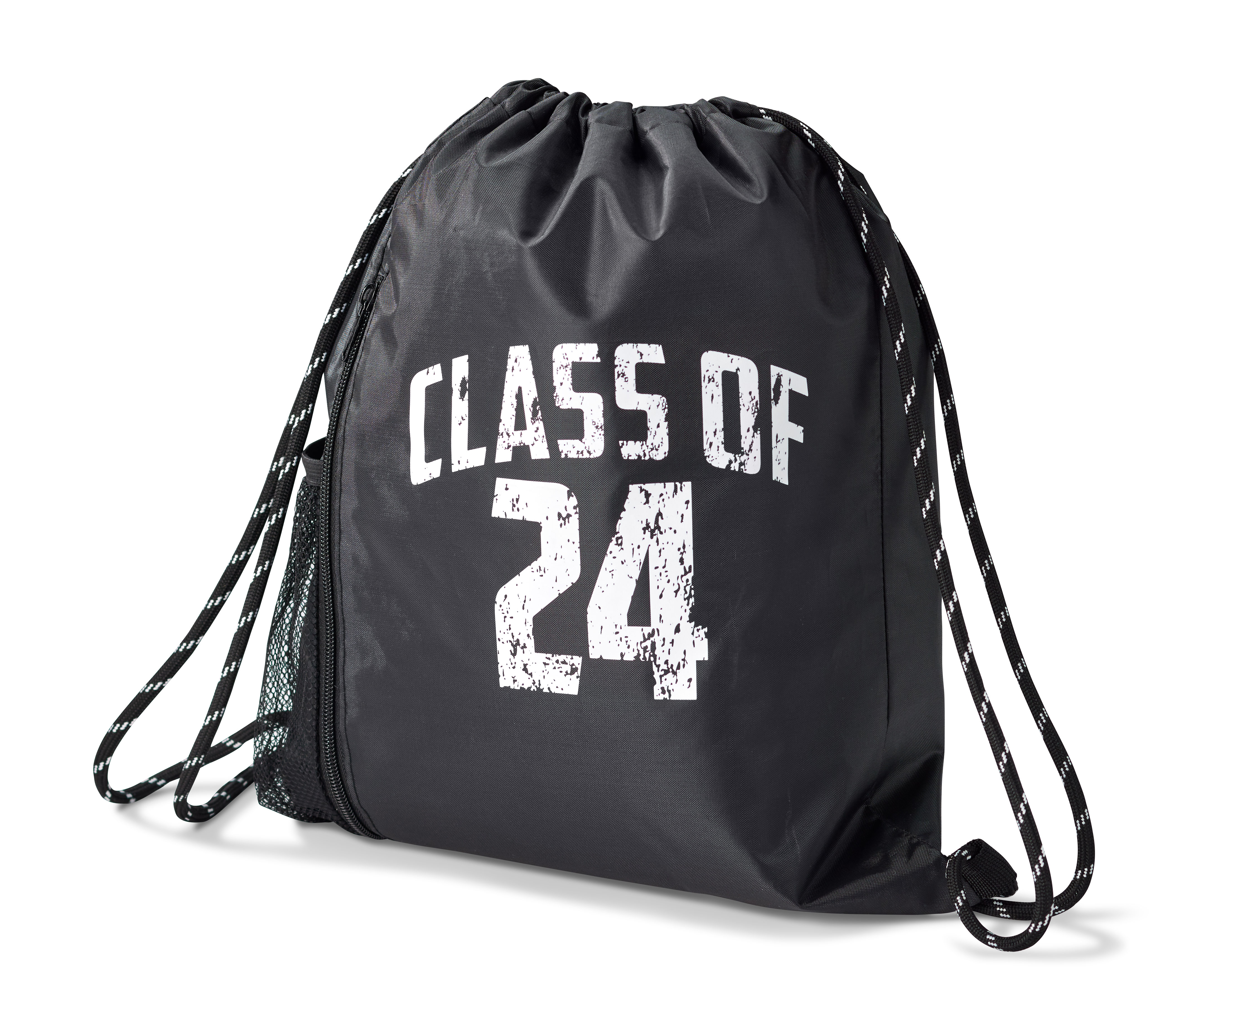

*BLACK Senior shirts will be worn the 24th of each month by ALL Seniors*

DEPOSIT: $100, $80, OR $60 – Cash, Check, Credit or Debit Cards will be accepted, or choose Grad Jpay to pay in 3 easy credit card installments. All Fall orders must be turned in before Nov. 24th
PAYMENTS: Invoices will be emailed a few weeks after order day. You will be able to make
payments by mail, phone or online. Total must be paid before delivery in the spring.
DELIVERY: Items shown above will be delivered on order day with paid deposit.
Items with *(On Order Form) will be shipped to your home 4 to 6 weeks after ordering with paid deposit.
Photo card items will be delivered to your home.
All other items will be delivered at school in the spring. Date to be announced.

Cap, Gown, Tassel Units are Included in ALL GRAD Packages
Required Items are different at each school. Please check your Order Form for pricing! *Make sure to mark Height and Weight in the last section of your order form.*
*ALL FALL ORDERS MUST BE TURNED IN BY NOV. 25TH*

JOSTENS Order Processing • 148 East Broadway St • Owatonna MN 55060 • 800-JOSTENS •
Email: www.jostens.com/contact


JostensCCS JostensCCS JostensCCS

Need to Customize your Class Ring or Lettermen’s Jacket?

